211521243084 – Karthikeyan S R

Phase -1 Documentation Submission

Phase -1 Problem definition and Design thinking

Covid-19 vaccines analysis

Contents

Objective: 2

Understanding the Problem: 3

Problem Scope: 3

Stakeholders: 3

Policymakers: 3

Health Organizations: 4

General Public: 4

1. Data Collection: 4

2. Data Preprocessing: 5

3. Exploratory Data Analysis (EDA): 5

4. Statistical Analysis: 6

5. Visualization: 6

6. Insights and Recommendations: 6

Conclusion: 7

Problem Statement

# Objective:

# The primary goal of this project is to conduct a comprehensive analysis of Covid-19 vaccine data, focusing on three critical aspects:

# Vaccine efficacy

# Vaccine distribution

# Vaccine’s adverse effects.

# By delving into these aspects, we aim to extract meaningful insights that will empower policymakers and health organizations in making informed decisions for optimizing vaccine deployment strategies.

Design Thinking:

# Understanding the Problem:

# Problem Scope:

The problem scope involves analysing a vast amount of Covid-19 vaccine data to discern the effectiveness of various vaccines, how they are distributed across different regions or demographics, and any adverse effects associated with them.

This analysis is crucial to respond effectively to the covid-19 pandemic and for planning future vaccination drives.

# Stakeholders:

## Policymakers:

Policymakers need insights to formulate effective policies and strategies for vaccine distribution and administration.

## Health Organizations:

Health organizations require data-driven insights to plan efficient vaccine deployment, ensuring maximum coverage and impact.

## General Public:

The general public needs transparent information about vaccine efficacy and safety to make informed decisions regarding their health.

Proposed Approach for the Problem Statement

# Data Collection:

We collect Covid-19 vaccine data from reputable sources like health organizations, government databases, and research publications. We will utilize the dataset available on Kaggle, specifically the "Covid-19 World Vaccination Progress" dataset as a foundational source for our analysis.

The dataset on Kaggle provides a comprehensive collection of data related to Covid-19 vaccinations worldwide, offering valuable insights into vaccination progress, coverage, and administration.

We can get the dataset from this link: <https://www.kaggle.com/datasets/gpreda/covid-world-vaccination-progress/code>

A small picture of the dataset is enclosed below:

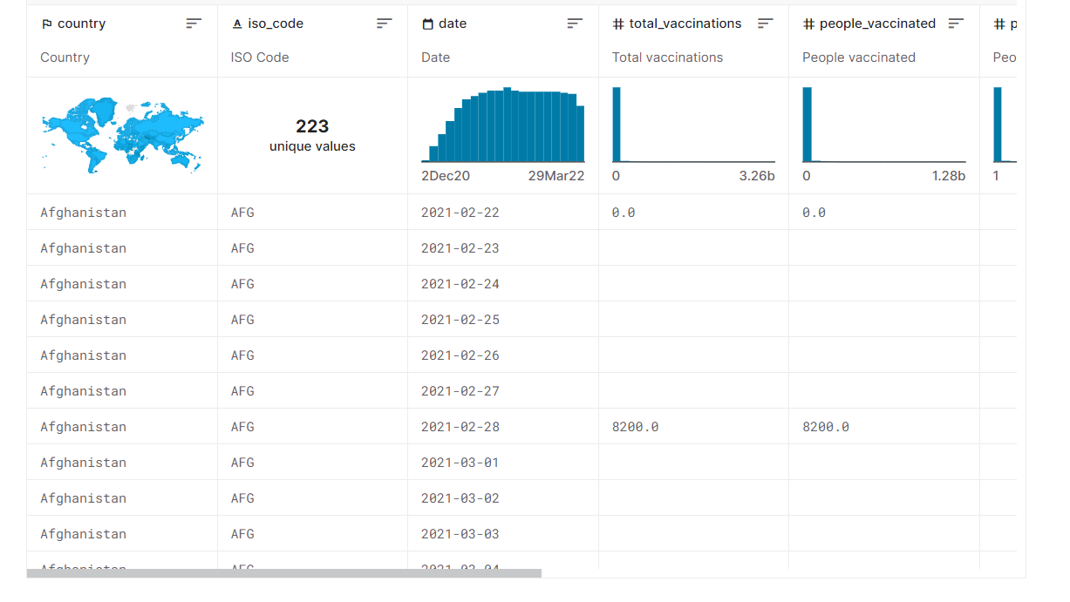

# Data Preprocessing:

Data preprocessing involves cleaning and organizing the collected data to ensure its quality and reliability for analysis.

Here, in this stage we address the missing values, remove duplicates, and convert the categorical data into numerical representations to facilitate analysis.

# **Exploratory Data Analysis (EDA):**

**EDA is a critical step to understand the structure and nuances of the data we've collected.**

**It involves visualizing the data to identify trends, patterns, and potential outliers, providing valuable insights that guide the subsequent analytical processes.**

**We can use python Or R to perform EDA.**

# **4. Statistical Analysis:**

**Statistical analysis is pivotal for drawing conclusions and making data-driven decisions.**

**We will conduct various statistical tests to determine vaccine efficacy, analyse adverse effects, and study the distribution of vaccines across different populations.**

# **5. Visualization:**

**Creating compelling visualizations is essential for effectively communicating the findings of our analysis to a diverse audience.**

**These visualizations will include bar plots, line charts, heatmaps, and other graphical representations that highlight key insights from the data analysis.**

**We can work in python/R or we can go with tools like PowerBI, Tableau, etc.**

# **6. Insights and Recommendations:**

**The ultimate objective of our analysis is to generate actionable insights that can be translated into recommendations.**

**These recommendations will be based on solid evidence derived from the analysis and will serve to guide policymakers and health organizations in optimizing vaccine deployment strategies.**

# **Conclusion:**

**In conclusion, this design thinking outlines a strategic approach for analysing Covid-19 vaccine data. By focusing on vaccine efficacy, distribution, and adverse effects, we aim to provide actionable insights for policymakers and health organizations.**

**Utilizing the comprehensive "Covid-19 World Vaccination Progress" dataset, we ensure a solid foundation for our analysis. The subsequent stages of data pre-processing, exploratory data analysis, statistical analysis, and visualization will enable us to uncover critical information for optimizing vaccine deployment strategies.**

**Understanding stakeholder interests is crucial, aligning our approach to meet their needs. Our objective is to generate actionable insights and recommendations, ultimately contributing to more effective public health strategies.**

**We look forward to moving ahead with this approach and leveraging data-driven insights to make a positive impact.**